Acceptance Test Procedure

Results (SKYDOC-XXXX)

For

Skyryse Flight OS LEMA TPX 325

Software Version: 1918900-0.9.3.112

|  |  |  |  |  |
| --- | --- | --- | --- | --- |
| LEMA Assembly Part Number | Operator | Condition | Serial Number | Test Start Time |
| LEMA | Shawn | Unhandled Type: Void | 12 | 3/10/2023 1:51:30 PM |

|  |  |  |
| --- | --- | --- |
| **Full Test Results:** | **Fail** | |
|  | | |
| **Group** | **Pass/Fail** | |
| **6.1. Visual Examination of the Product** | Pass | |
| **6.2 Weight** | Fail | |
| 6.3 Bonding | Fail | |
| **6.4 Resistance** and Inductance Test **(motor and solenoid)** | Fail | Fail |
| **6.5 Power ON UUT Checks** | Pass | |
| **6.6 Functional Check Out** | Pass | |
| **6.6.3 Holding Load Test** | Fail | Fail |
| **6.6.4 Brake Release** | Pass | |
| **6.6.5 N1 and N2 Extend Mechanical Stops and MCE Rigging** | Fail | |
| **6.6.6 N1 and N2 Stroke** | Fail | |
| **6.6.7 Performance Test – unloaded operation (one channel operation)** | Fail | |
| **6.6.8 Performance Test – Loaded Operation** | Fail | |
| **6.6.9 Backlash** | Fail | |

**6.1. Visual Examination of the Product**

|  |  |
| --- | --- |
| UUT conforms to the requirements of paragraph 6.1 | Pass |

**6.2 Weight**

|  |  |  |
| --- | --- | --- |
| **UUT Weight** | | |
| **Requirements** | **Results** | |
| UUT weight should not exceed 10 lbs | actual weight Unhandled Type: Void lbs | Unhandled Type: Void |

6.3 Bonding

**Bonding resistance:**

|  |  |  |  |  |  |
| --- | --- | --- | --- | --- | --- |
| **Bonding Resistance** | | | | | |
| **Requirements** | | | **Results** | | |
|  | **Expected** | **Tolerance** | **Simplex** | **Duplex** | **Units** |
| Motor End Cap | 10 | 0.5 | 3 | 0 | (mOhms) |
| Solenoid housing | 10 | 0.5 | 4 | 5 | (mOhms) |
| Encoder cover | 7.5 | 0.5 | 3 | 0 | (mOhms) |
| All Bonding Pass/Fail | | | Fail | |  |

**6.4 Resistance and Inductance Test** **(motor and solenoid)**

**Resistances:**

|  |  |  |  |  |  |  |
| --- | --- | --- | --- | --- | --- | --- |
| **Motor and Solenoid Resistances** | | | | | | |
| **Requirements** | | | **Results** | | | |
| Pins | **Expected** | **Tolerance** | **Connector J1** | **Connector J2** | **Connector J3** | **Units** |
| E to F | 0.212 | 0.0212 | 2 | 0 | 0 | (Ohms) |
| F to G | 0.212 | 0.0212 | 3 | 0 | 0 | (Ohms) |
| G to E | 0.212 | 0.0212 | 2 | 0 | 3 | (Ohms) |
| A to L | 6.55 | 0.44 | 0 | 2 | 0 | (Ohms) |
| G,F,E,A,L tied together to chassis grounds. Apply 500VDC | 5000000 | 0 | 0 | 0 | 0 | (Ohms) |
| All Resistances Pass/Fail | | | Fail | | |  |

**Inductances:**

|  |  |  |  |  |  |  |
| --- | --- | --- | --- | --- | --- | --- |
| **Motor and Solenoid Inductances** | | | | | | |
| **Requirements** | | | **Results** | | | |
|  | **Expected** | **Tolerance** | **Connector J1** | **Connector J2** | **Connector J3** | **Units** |
| E to F | 0.155 | 0.02325 | 0 | 0 | 0 | (mH) |
| F to G | 0.155 | 0.02325 | 0 | 0 | 0 | (mH) |
| G to E | 0.155 | 0.02325 | 0 | 0 | 0 | (mH) |
| A to L | 22 | 3.3 | 0 | 2 | 0 | (mH) |
| All Inductances Pass/Fail | | | Fail | | |  |

**6.5 Power ON UUT Checks**

Confirm all sensors are reporting nominal values and no faults reported

|  |  |  |  |
| --- | --- | --- | --- |
| **Power ON UUT Checks** | | | |
| **Description** | **Results** | | |
| **Sensor** | **Value** | **Units** | **Pass/Fail** |
| Motor 1 | 0.0000 | in | Pass |
| Motor 2 | 0.0000 | in | Pass |
| Motor 3 | -0.0057 | in | Pass |
| M1 | 0.0000 | in | Pass |
| M2 | 0.0000 | in | Pass |
| M3 | 0.0000 | in | Pass |
| Faults 1 | 1024 | Code | Pass |
| Faults 2 | 1024 | Code | Pass |
| Faults 3 | 1024 | Code | Pass |

**6.6 Functional Check Out**

**6.6.1 MCE1, MCE 2, MCE3 Power Up**

|  |  |  |  |  |
| --- | --- | --- | --- | --- |
| **Functional Check Out** | | | | |
| **Requirements** | **Results** | | | |
| **Description** | **Ballnut position** | **Units** | **Pass/Fail** | |
| MCE 1 reports values for Ballnut position and motor current | 0 | in | Ballnut Position | Current |
| Pass | Pass |
| (Simulated) FCC/reports values for M1(QPS) | -0 | in | Pass |  |
| MCE 2 reports values for Ballnut position and motor current | 0 | in | Pass | Pass |
| (Simulated) FCC/reports values for M2(QPS) | -0 | in | Pass |  |
| MCE 3 reports values for Ballnut position and motor current | -0.0068 | in | Pass | Pass |
| (Simulated) FCC/reports values for M3(QPS) | -0 | in | Pass |  |

**6.6.3 Holding Load Test**

**6.6.3.1 Brake OFF, LEMA Output Locked**

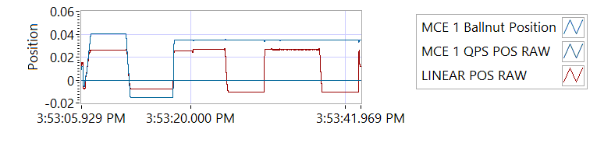

Figure -Hold Brake OFF for MCE 1

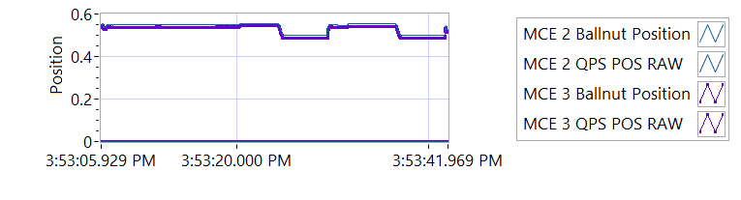

Figure -Hold Brake OFF for MCE 2

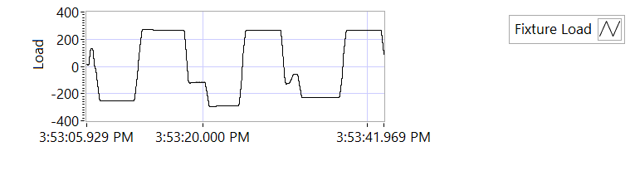

Figure -Hold Brake OFF for MCE 3

|  |  |  |  |  |  |
| --- | --- | --- | --- | --- | --- |
| **Holding Load Test - Brake OFF, LEMA Output Locked** | | | | | |
| **Requirements** | | | **Results** | | |
| **MCE** | **Expected Output Force/Amps** | **Tolerance** | **Actual Output force/Amps** | **Units** | **Output force/Amps, Pass/Fail** |
| MCE 1, 6.6.3.1.1 step d/e– extend 0.4 in, Sustain 12.6 Amps (TBC) current limit for 3-5 seconds | 562.5 | 237.5 | -252.5952 | lbf | Failed |
| 12.6 | 8.0 | 6.0075 | A | Pass |
| MCE 1, 6.6.3.1.1 step f/g - retract 0.4 in, Sustain 12.6 Amps (TBC) current limit for 3-5 seconds | 562.5 | 237.5 | 267.0797 | lbf | Failed |
| -12.6 | 8.0 | -6.0025 | A | Pass |
| MCE 2, 6.6.3.1.2 step d/e– extend 0.4 in, Sustain 12.6 Amps (TBC) current limit for 3-5 seconds | 562.5 | 237.5 | -291.5039 | lbf | Failed |
| 12.6 | 8.0 | 5.9964 | A | Pass |
| MCE 2, 6.6.3.1.2 step f/g - retract 0.4 in, Sustain 12.6 Amps (TBC) current limit for 3-5 seconds | 562.5 | 237.5 | 264.6477 | lbf | Failed |
| -12.6 | 8.0 | -5.9935 | A | Pass |
| MCE 3, 6.6.3.1.3 step d/e– extend 0.4 in, Sustain 12.6 Amps (TBC) current limit for 3-5 seconds | 562.5 | 237.5 | -228.9131 | lbf | Failed |
| 12.6 | 8.0 | 5.9946 | A | Pass |
| MCE 3, 6.6.3.1.3 step f/g - retract 0.4 in, Sustain 12.6 Amps (TBC) current limit for 3-5 seconds | 562.5 | 237.5 | 264.8116 | lbf | Failed |
| -12.6 | 8.0 | -6.0101 | A | Pass |

**6.6.3.2 Brake ON, LEMA Output Free**

|  |  |  |  |  |  |  |
| --- | --- | --- | --- | --- | --- | --- |
| **Holding Load Test - Brake ON, LEMA Output Free**  **12.6 +- 8 Amps for 3-5 sec** | | | | | | |
| **Requirements** | **Results** | | | | | |
| **MCE** | **MCE Current** | **Units** | **Current Pass/Fail** | **Position feedback** | **Units** | **Position Feedback Pass/Fail** |
| MCE 1, 6.6.3.2.1 step I – extend 0.4 in | 5.9979 | A | Pass | -0.0031 | in | Pass |
| MCE 1, 6.6.3.2.1 step k - retract 0.4 in | -5.9991 | A | True | -0.0047 | in | Pass |
| MCE 2, 6.6.3.2.2 step i – extend 0.4 in | 5.9989 | A | True | -0.0102 | in | Pass |
| MCE 2, 6.6.3.2.2 step k - retract 0.4 in | -6.0028 | A | True | -0.011 | in | Pass |
| MCE 3, 6.6.3.2.3 step I – extend 0.4 in | 5.9832 | A | True | -0.0118 | in | Pass |
| MCE 3, 6.6.3.2.3 step k - retract 0.4 in | -5.9992 | A | True | -0.0118 | in | Pass |

**6.6.4 Brake Release Test**

**Step d –** LEMA reaches commanded position.

|  |  |  |  |  |  |
| --- | --- | --- | --- | --- | --- |
| **Brake Release Test** | | | | | |
| **Requirements** | | | **Results** | | |
| Description | Expected | Tolerance | Position | Units | Pass/Fail |
| MCE1 /Motor 1 | 0.4 | 0.05 | 0.400 | in | Pass |
| MCE2 /Motor 2 | 0.4 | 0.05 | 0.400 | in | Pass |
| MCE3 /Motor 3 | 0.4 | 0.05 | 0.400 | in | Pass |

**6.6.5 N1 and N2 Extend Mechanical Stops and MCE Rigging**

**Step 6.6.5.1** **Extend using M1/N1**

|  |  |  |  |
| --- | --- | --- | --- |
| **Extend using M1/N1** | | | |
| **Requirements** | **Results** | | |
| **Description** | **Value** | **Units** | **Pass/Fail** |
| N1 extend stop engaged (M1 current saturated) | 1024 | Code | Pass |
| MCE 1 Motor Current 4.5 +/- 0.15 Amps | 6.0066 | Amps | Failed |
| Linear Encoder Value | -0.4809 | in | Pass |
| N1 is Rigged | 0 | Code | Pass |

**Step 6.6.5.2** **Extend using M2/N2**

|  |  |  |  |
| --- | --- | --- | --- |
| **Extend using M2/N2** | | | |
| **Requirements** | **Results** | | |
| **Description** | **Value** | **Units** | **Pass/Fail** |
| N2 extend stop engaged (M2 current saturated) | 1024 | Code | Pass |
| MCE2 Motor Current 4.5 +/- 0.15 Amps | 5.9889 | Amps | Failed |
| Linear Encoder Value | -0.4179 | in | Pass |
| N2 (Motor 2) is Rigged | 0 | Code | Pass |
| N2 (Motor 3) is Rigged | 0 | Code | Pass |

**6.6.6 N1 and N2 Stroke Check**

|  |  |  |  |
| --- | --- | --- | --- |
| **N1 and N2 Stroke Check Position** | | | |
| **Requirements** | **Results** | | |
| **Pin to pin Length is 16.732 +/- TBD (ins)** | **Pin to Pin Length** | **Units** | **Pass/Fail** |
|  | in |  |
| **Requirements** | **Results** | | |
| **Description** | **Actual Position N1/N2** |  | **Pass/Fail** |
| N2 at -0.575 ins from Null using M2 | -0.575 | in | Pass |
| N1 at +1.725 ins from Null using M1 | 1.725 | in | Pass |
| N1 at -0.575 ins from Null using M1 | -0.575 | in | Pass |
| N2 at +1.725 ins from NULL using M2 | 1.7257 | in | Pass |
| N1 at -0.575 ins from Null using M1 | -0.575 | in | Pass |
| N2 at +1.725 ins from Null using M3 | 1.7244 | in | Pass |
| N2 at -0.575 ins from Null using M3 | -0.5744 | in | Pass |

|  |  |  |  |  |  |
| --- | --- | --- | --- | --- | --- |
| **All Motor Stroke Check Description** | | | | | |
| **Requirements** | | | **Results** | | |
| **Description** | **Expected Difference from Test rig encoder** | **Tolerance** | **Difference from Test rig encoder** | **Units** | **Pass/Fail** |
| Motor 1 position + Motor 2 position = test rig encoder | 0 | 0.1 | 0.0139 | in | Pass |
| Motor1 position + Motor 3 position = test rig encoder | 0 | 0.1 | 0.0139 | in | Pass |
| M1 position + M2 position = test rig encoder | 0.1 | 0.1 | -0.3602 | in | Failed |
| M1 position + M3 position = test rig encoder | 0 | 0.1 | -0.3602 | in | Failed |
| Difference between Motor 2 position and Motor 3 position is < TBD ins | 0 | 0.1 | 0 | in | Pass |
| Difference between M2 position and M3 position is < TBD ins | 0 | 0 | 0 | in | Pass |
| Difference between Motor 1 position and M1 position is < TBD ins | 0 | 0.1 | 0.949 | in | Failed |
| Difference between Motor 2 position and M2 position is < TBD ins | 0 | 0.1 | 0.575 | in | Failed |
| Difference between Motor 3 position and M3 position is < TBD ins | 0 | 0.1 | 0.575 | in | Failed |

MOTOR 1

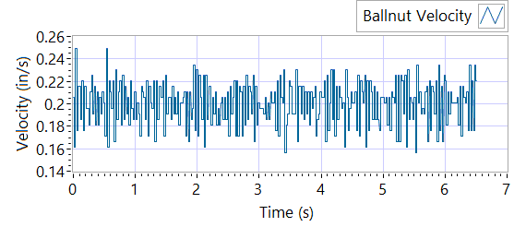

Figure - Ballnut Velocity for Motor One

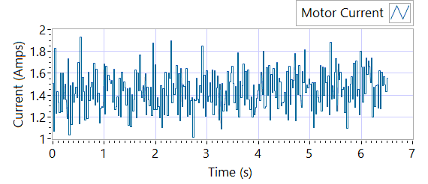

Figure -Current for Motor One

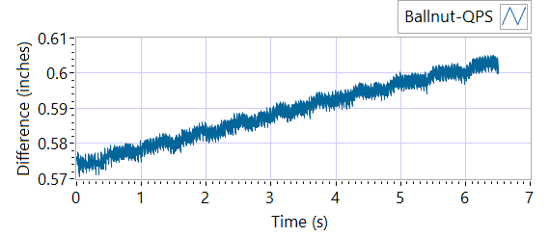

Figure - M1 Delta for Motor One

|  |  |  |  |  |  |  |
| --- | --- | --- | --- | --- | --- | --- |
| **MOTOR 1 STROKE CHECK** | | | | | | |
| **Requirements** | | | **Results** | | | |
| **Description** | **Expected** | **Tolerance** | **Actual Average** | **Peak Velocity** | **Units** | **Pass/Fail** |
| Constant Velocity | 0.2 | 0.02 | 0.2 | 0.2 | In/s | Pass |
| **Description** | **Expected** | **Tolerance** | **Actual** | **Standard Deviation** | **Units** | **Pass/Fail** |
| Delta between Motor 1 Position and M1 position | 0.1 | 0.2 | 1.5977 | 0.0087 | in | Failed |
| Delta between Motor 1 Position and Linear Encoder position | 0.1 | 0.2 | 0.6052 | 0.376 | in | Failed |
| Motor Current |  |  | 1.439 | 0.1785 | Amps |  |

MOTOR 2

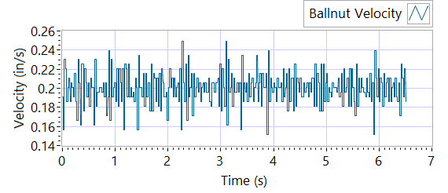

Figure - Ballnut Velocity for Motor Two

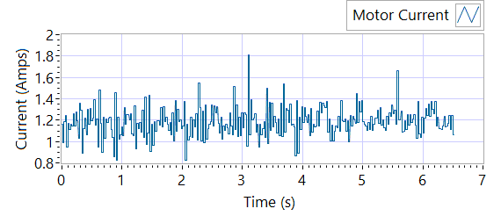

Figure -Current for Motor Two

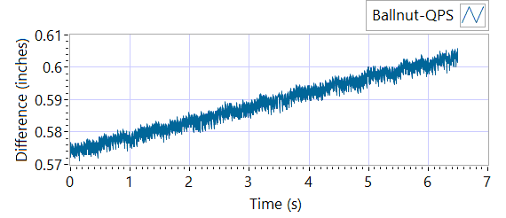

Figure - M1 Delta for Motor Two

|  |  |  |  |  |  |  |
| --- | --- | --- | --- | --- | --- | --- |
| **MOTOR 2 STROKE CHECK** | | | | | | |
| **Requirements** | | | **Results** | | | |
| **Description** | **Expected** | **Tolerance** | **Actual Average** | **Peak Velocity** | **Units** | **Pass/Fail** |
| Constant Velocity | 0.2 | 0.02 | 0.2 | 0.2 | In/s | Pass |
| **Description** | **Expected** | **Tolerance** | **Actual** | **Standard Deviation** | **Units** | **Pass/Fail** |
| Delta between Motor 2 Position and M2 position | 0.1 | 0.2 | 1.5999 | 0.0084 | Inches | Failed |
| Delta between Motor 2 Position and Linear Encoder position | 0.1 | 0.2 | 0.6045 | 0.376 | Inches | Failed |
| Motor Current |  |  | 1.1851 | 0.1328 | Amps |  |

MOTOR 3

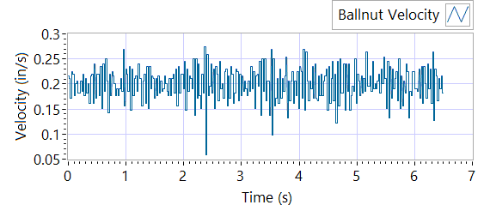

Figure - Ballnut Velocity for Motor Three

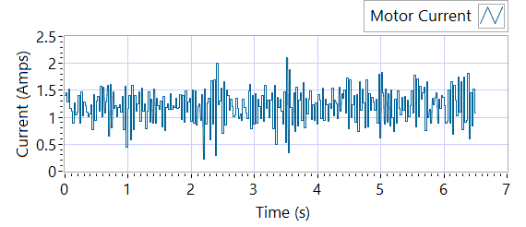

Figure -Current for Motor Three



Figure - M3 Delta for Motor Three

|  |  |  |  |  |  |  |
| --- | --- | --- | --- | --- | --- | --- |
| **MOTOR 3 STROKE CHECK** | | | | | | |
| **Requirements** | | | **Results** | | | |
| **Description** | **Expected** | **Tolerance** | **Actual Average** | **Peak Velocity** | **Units** | **Pass/Fail** |
| Constant Velocity | 0.2 | 0.02 | 0.1998 | 0.1998 | In/s | Pass |
| **Description** | **Expected** | **Tolerance** | **Actual** | **Standard Deviation** | **Units** | **Pass/Fail** |
| Delta between Motor 3 Position and M3 position | 0.1 | 0.2 | 1.5866 | 0.0087 | in | Failed |
| Delta between Motor 3 Position and Linear Encoder position | 0.1 | 0.2 | 0.606 | 0.3753 | in | Failed |
| Motor Current |  |  | 1.2039 | 0.3068 | Amps |  |

**6.6.7 Performance Test – unloaded operation (one channel operation)**

**6.6.7.1.1 MCE 1 - Step Response Test**

**The result for motor one is shown below:**

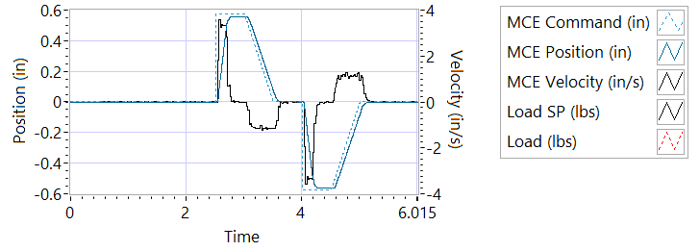

Figure - Results for Motor One

**Step d Extension**

|  |  |  |  |
| --- | --- | --- | --- |
| **MCE 1 - Step Response Extension Unloaded** | | | |
| **Requirements** | **Results** | | |
| **Description** | **Actual Speed / Time** | **Units** | **Pass/Fail** |
| No Load speed is 2.7 to 3.3 in/sec | 3.2334 | In/s | True |
| Time to achieve 80% of the specified stroke (+ 0.575 ins) is 170+9/-9 ms | 0.1987 | seconds | Failed |

**Step e Retraction**

|  |  |  |  |
| --- | --- | --- | --- |
| **MCE 1 - Step Response Retraction Unloaded** | | | |
| **Requirements** | **Results** | | |
| **Description** | **Actual Speed / Time** | **Units** | **Pass/Fail** |
| No Load speed is 2.7 to 3.3 in/sec | -3.2903 | In/s | True |
| Time to achieve 80% of the specified stroke (- 0.575 ins) is 170+9/-9 ms | 0.193 | seconds | Failed |

**6.6.7..1.2 MCE 1 - Frequency Response**

**Step d**

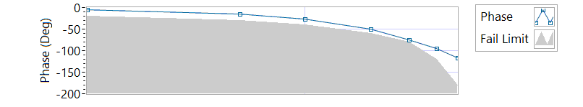

Figure - Phase for Motor One

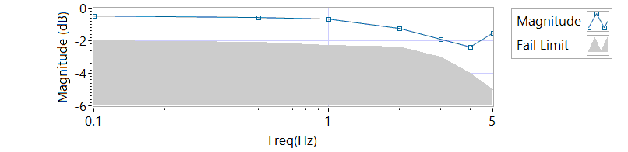

Figure - Magnitude for Motor One

**Frequency Response**

|  |  |  |  |  |
| --- | --- | --- | --- | --- |
| **MCE 1 - Frequency Response Unloaded** | | | | |
| **Frequency**  **(Hz)** | **Magnitude**  **(dB)** | **Phase**  **(deg)** | **Max Phase**  **Allowance (deg)** | **Pass/Fail** |
| 0.1 Hz | -0.496882 | -4.8996 | -20 | Pass |
| 0.5 Hz | -0.554983 | -15.048 | -30 | Pass |
| 1 Hz | -0.642865 | -26.568 | -40 | Pass |
| 2 Hz | -1.23687 | -50.4 | -60 | Pass |
| 3 Hz | -1.92383 | -75.6 | -80 | Pass |
| 4 Hz | -2.36206 | -94.896 | -120 | Pass |
| 5 Hz | -1.50144 | -117.18 | -180 | Pass |

6.6.7.2.1 **MCE 2 - Step Response Test**

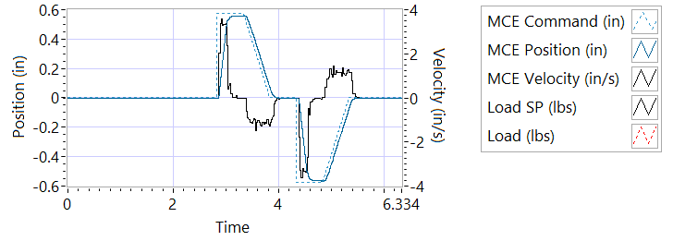

Figure - Results for Motor Two

**Step d Extension**

|  |  |  |  |
| --- | --- | --- | --- |
| **MCE 2 - Step Response Extension Unloaded** | | | |
| **Requirements** | **Results** | | |
| **Description** | **Actual Speed / Time** | **Units** | **Pass/Fail** |
| No Load speed is 2.7 to 3.3 in/sec | 3.2804 | In/s | Pass |
| Time to achieve 80% of the specified stroke (+ 0.575 ins) is 170+9/-9 ms | 0.1913 | seconds | Failed |

**Step e Retraction**

|  |  |  |  |
| --- | --- | --- | --- |
| **MCE 2 - Step Response Retraction Unloaded** | | | |
| **Requirements** | **Results** | | |
| **Description** | **Actual Speed / Time** | **Units** | **Pass/Fail** |
| No Load speed is 2.7 to 3.3 in/sec | -3.2613 | In/s | Pass |
| Time to achieve 80% of the specified stroke (- 0.575 ins) is 170+9/-9 ms | 0.2148 | seconds | Failed |

6.6.7.2.2 **MCE 2 - Frequency Response Test**

**Step d**

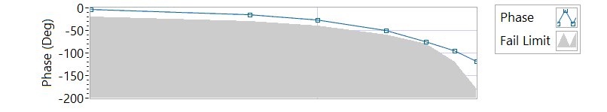

Figure - Phase for Motor Two

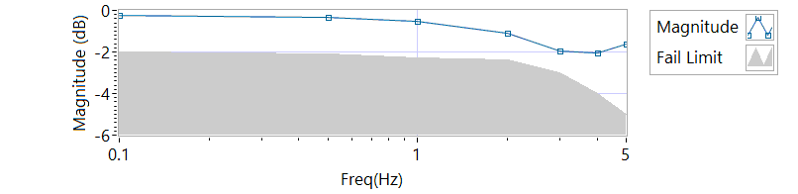

Figure - Magnitude for Motor Two

**Frequency Response**

|  |  |  |  |  |
| --- | --- | --- | --- | --- |
| **MCE 2 - Frequency Response Unloaded** | | | | |
| **Frequency (Hz)** | **Magnitude**  **(db)** | **Phase**  **(Deg)** | **Max Phase**  **Allowance (Deg)** | **Pass/Fail** |
| 0.1 Hz | -0.254203 | -3.8412 | -20 | Pass |
| 0.5 Hz | -0.339084 | -15.3 | -30 | Pass |
| 1 Hz | -0.511368 | -26.892 | -40 | Pass |
| 2 Hz | -1.11167 | -49.68 | -60 | Pass |
| 3 Hz | -1.95965 | -74.412 | -80 | Pass |
| 4 Hz | -2.06334 | -95.184 | -120 | Pass |
| 5 Hz | -1.63513 | -117.9 | -180 | Pass |

6.6.7.3.1 **MCE 3 – Step Response Test**

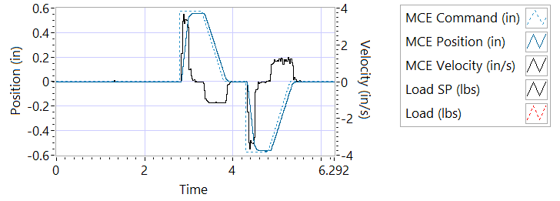

Figure - Results for Motor Three

**Step d Extension**

|  |  |  |  |
| --- | --- | --- | --- |
| **MCE 3 – Step Response Extension Unloaded** | | | |
| **Requirements** | **Results** | | |
| **Description** | **Actual Speed / Time** | **Units** | **Pass/Fail** |
| No Load speed is 2.7 to 3.3 in/sec | 3.2881 | In/s | Pass |
| Time to achieve 80% of the specified stroke (+ 0.575 ins) is 170+9/-9 ms | 0.2017 | seconds | Failed |

**Step e Retraction**

|  |  |  |  |
| --- | --- | --- | --- |
| **MCE 3 – Step Response Retraction Unloaded** | | | |
| **Requirements** | **Results** | | |
| **Description** | **Actual Speed / Time** | **Units** | **Pass/Fail** |
| No Load speed is 2.7 to 3.3 in/sec | -3.2656 | In/s | Pass |
| Time to achieve 80% of the specified stroke (- 0.575 ins) is 170+9/-9 ms | 0.1984 | seconds | Failed |

6.6.7.3.2 **MCE 3 Frequency Response Test**

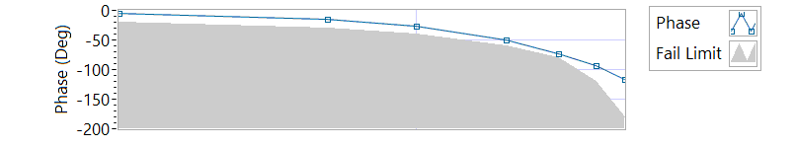

Figure - Phase for Motor Three

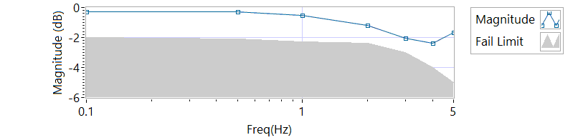

Figure - Magnitude for Motor Three

**Step d**

|  |  |  |  |  |
| --- | --- | --- | --- | --- |
| **MCE 3 Frequency Response Unloaded** | | | | |
| **Frequency**  **(Hz)** | **Magnitude**  **(dB)** | **Phase**  **(Deg)** | **Max Phase**  **Allowance (Deg)** | **Pass/Fail** |
| 0.1 Hz | -0.282405 | -4.3632 | -20 | Pass |
| 0.5 Hz | -0.296539 | -15.012 | -30 | Pass |
| 1 Hz | -0.540418 | -26.352 | -40 | Pass |
| 2 Hz | -1.17405 | -50.472 | -60 | Pass |
| 3 Hz | -2.02845 | -72.792 | -80 | Pass |
| 4 Hz | -2.36301 | -93.888 | -120 | Pass |
| 5 Hz | -1.67821 | -115.92 | -180 | Pass |

**6.6.8 Performance Test – Loaded Operation**

**6.6.8.1 Step and Frequency Response Test - Loaded**

**6.6.8.1.1 MCE1 – Step Response Test**

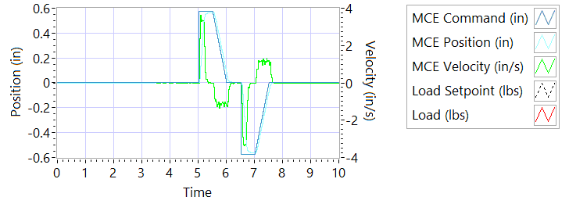

Figure - Results for Motor One Loaded

Step response Test

**Step j – 225 lbf tension - Extension**

|  |  |  |  |
| --- | --- | --- | --- |
| **MCE1 – Step Response Tension Extension** | | | |
| **Requirements** | **Results** | | |
| **Description** | **Actual Speed / Time** | **Units** | **Pass/Fail** |
| No Load speed is 2.7 to 3.3 in/sec | 3.24 | In/s | Pass |
| Time to achieve 80% of the specified stroke (+ 0.575 ins) is 170+9/-9 ms | 0.2041 | seconds | Failed |

**Step k – 225 lbf tension - Retraction**

|  |  |  |  |
| --- | --- | --- | --- |
| **MCE1 – Step Response Tension Retraction** | | | |
| **Requirements** | **Results** | | |
| **Description** | **Actual Speed / Time** | **Units** | **Pass/Fail** |
| No Load speed is 2.7 to 3.3 in/sec | -3.2962 | In/s | Pass |
| Time to achieve 80% of the specified stroke (- 0.575 ins) is 170+9/-9 ms | 0.2138 | seconds | Failed |

**Step n – 225 lbf compression - Extension**

|  |  |  |  |
| --- | --- | --- | --- |
| **MCE1 – Step Response Compression Extension** | | | |
| **Requirements** | **Results** | | |
| **Description** | **Actual Speed / Time** | **Units** | **Pass/Fail** |
| No Load speed is 2.7 to 3.3 in/sec | 3.2822 | In/s | Pass |
| Time to achieve 80% of the specified stroke (+0.575 ins) is 170+9/-9 ms | 0.2103 | seconds | Failed |

**Step o – 225 lbf compression - Retraction**

|  |  |  |  |
| --- | --- | --- | --- |
| **MCE1 – Step Response Compression Retraction** | | | |
| **Requirements** | **Results** | | |
| **Description** | **Actual Speed / Time** | **Units** | **Pass/Fail** |
| No Load speed is 2.7 to 3.3 in/sec | -3.24 | In/s | Pass |
| Time to achieve 80% of the specified stroke (-0.575 ins) is 170+9/-9 ms | 0.1931 | seconds | Failed |

**6.6.8.1.2 MCE 1 – Frequency Response Test**

**Step d – 225 lbf Tension**

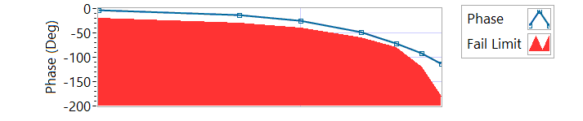

Figure - Phase for Motor One Loaded Tension

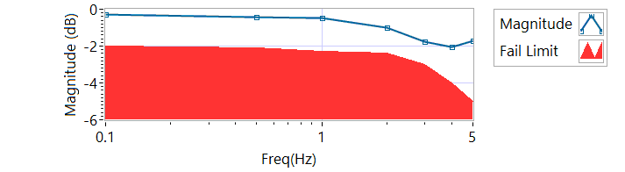

Figure - Magnitude for Motor One Loaded Tension

|  |  |  |  |  |
| --- | --- | --- | --- | --- |
| **MCE 1 – Tension Frequency Response** | | | | |
| **Frequency**  **(Hz)** | **Magnitude**  **(dB)** | **Phase**  **(Deg)** | **Max Phase**  **Allowance (Deg)** | **Pass/Fail** |
| 0.1 HZ | -0.268291 | -4.14 | -20 | Pass |
| 0.5 HZ | -0.424798 | -13.788 | -30 | Pass |
| 1 HZ | -0.467975 | -25.056 | -40 | Pass |
| 2 HZ | -1.00358 | -48.312 | -60 | Pass |
| 3 HZ | -1.75646 | -70.956 | -80 | Pass |
| 4 HZ | -2.04439 | -92.304 | -120 | Pass |
| 5 HZ | -1.7057 | -113.76 | -180 | Pass |

**Step h – 225 lbf Compression**

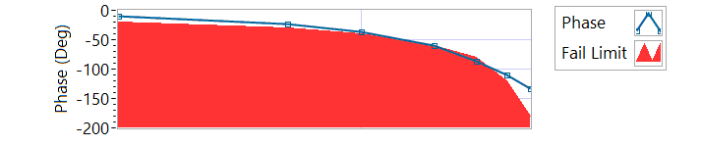

Figure - Phase for Motor One Loaded Compression

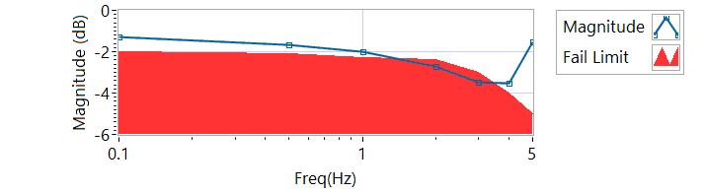

Figure - Magnitude for Motor One Loaded Compression

|  |  |  |  |  |
| --- | --- | --- | --- | --- |
| **MCE 1 – Compression Frequency Response** | | | | |
| **Frequency**  **(Hz)** | **Magnitude**  **(dB)** | **Phase**  **(Deg)** | **Max Phase**  **Allowance (Deg)** | **Pass/Fail** |
| 0.1 HZ | -1.26846 | -10.3752 | -20 | Pass |
| 0.5 HZ | -1.68987 | -22.752 | -30 | Pass |
| 1 HZ | -1.9769 | -36.432 | -40 | Pass |
| 2 HZ | -2.71085 | -60.768 | -60 | Failed |
| 3 HZ | -3.48589 | -85.968 | -80 | Failed |
| 4 HZ | -3.50398 | -110.016 | -120 | Pass |
| 5 HZ | -1.52989 | -133.74 | -180 | Pass |

**6.6.8.2.1 MCE 2 – Step Response Test**

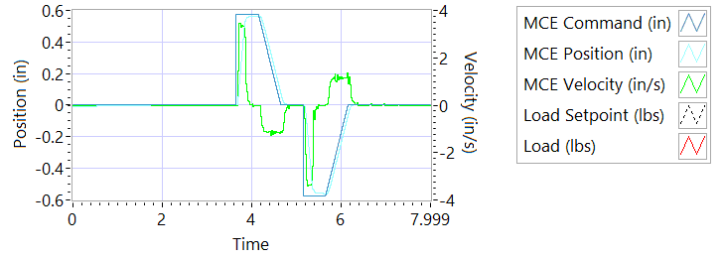

Figure - Results for Motor Two Loaded Tension

**Step j – 225 lbf tension - Extension**

|  |  |  |  |
| --- | --- | --- | --- |
| **MCE2 – Step Response Tension Extension** | | | |
| **Requirements** | **Results** | | |
| **Description** | **Actual Speed / Time** | **Units** | **Pass/Fail** |
| No Load speed is 2.7 to 3.3 in/sec | 3.2421 | In/s | Pass |
| Time to achieve 80% of the specified stroke (+ 0.575 ins) is 170+9/-9 ms | 0.1973 | seconds | Failed |

**Step k – 225 lbf tension - Retraction**

|  |  |  |  |
| --- | --- | --- | --- |
| **MCE2 – Step Response Tension Retraction** | | | |
| **Requirements** | **Results** | | |
| **Description** | **Actual Speed / Time** | **Units** | **Pass/Fail** |
| No Load speed is 2.7 to 3.3 in/sec | -3.3037 | In/s | Pass |
| Time to achieve 80% of the specified stroke (- 0.575 ins) is 170+9/-9 ms | 0.2088 | seconds | Failed |

**Step n – 225 lbf compression - Extension**

|  |  |  |  |
| --- | --- | --- | --- |
| **MCE2 – Step Response Compression Extension** | | | |
| **Requirements** | **Results** | | |
| **Description** | **Actual Speed / Time** | **Units** | **Pass/Fail** |
| No Load speed is 2.7 to 3.3 in/sec | 3.3228 | In/s | Pass |
| Time to achieve 80% of the specified stroke (+0.575 ins) is 170+9/-9 ms | 0.2027 | seconds | Failed |

**Step o – 225 lbf compression - Retraction**

|  |  |  |  |
| --- | --- | --- | --- |
| **MCE2 – Step Response Compression Retraction** | | | |
| **Requirements** | **Results** | | |
| **Description** | **Actual Speed / Time** | **Units** | **Pass/Fail** |
| No Load speed is 2.7 to 3.3 in/sec | -3.2322 | In/s | Pass |
| Time to achieve 80% of the specified stroke (-0.575 ins) is 170+9/-9 ms | 0.1954 | seconds | Failed |

**6.6.8.2.2 MCE 2 – Frequency response Test**

**Step d – 225 lbf Tension**

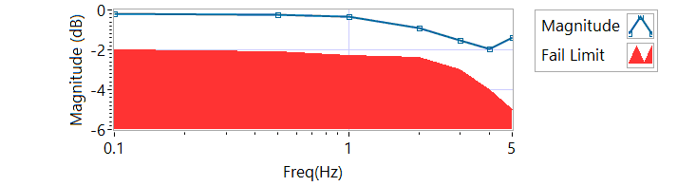

Figure - Magnitude for Motor Two Loaded Tension

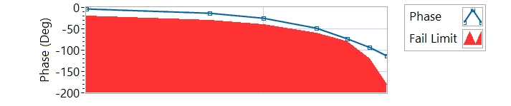

Figure - Phase for Motor Two Loaded Tension

|  |  |  |  |  |
| --- | --- | --- | --- | --- |
| **MCE 2 – Frequency response Tension** | | | | |
| **Frequency**  **(Hz)** | **Magnitude**  **(dB)** | **Phase**  **(Deg)** | **Max Phase**  **Allowance (Deg)** | **Pass/Fail** |
| 0.1 HZ | -0.1841 | -3.0456 | -20 | Pass |
| 0.5 HZ | -0.226094 | -12.618 | -30 | Pass |
| 1 HZ | -0.339084 | -24.66 | -40 | Pass |
| 2 HZ | -0.896814 | -48.384 | -60 | Pass |
| 3 HZ | -1.54158 | -72.792 | -80 | Pass |
| 4 HZ | -1.95563 | -93.744 | -120 | Pass |
| 5 HZ | -1.38647 | -114.12 | -180 | Pass |

**Step h – 225 lbf Compression**

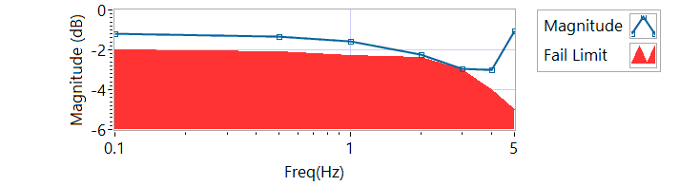

Figure - Magnitude for Motor Two Loaded Compression

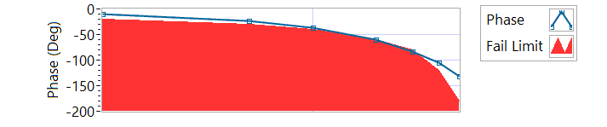

Figure - Phase for Motor Two Loaded Compression

|  |  |  |  |  |
| --- | --- | --- | --- | --- |
| **MCE 2 – Frequency response Compression** | | | | |
| **Frequency**  **(Hz)** | **Magnitude**  **(dB)** | **Phase**  **(Deg)** | **Max Phase**  **Allowance (Deg)** | **Pass/Fail** |
| 0.1 HZ | -1.2054 | -10.8216 | -20 | Pass |
| 0.5 HZ | -1.34793 | -22.608 | -30 | Pass |
| 1 HZ | -1.59079 | -35.856 | -40 | Pass |
| 2 HZ | -2.25598 | -60.192 | -60 | Failed |
| 3 HZ | -2.94956 | -83.7 | -80 | Failed |
| 4 HZ | -2.9863 | -105.12 | -120 | Pass |
| 5 HZ | -1.04897 | -131.4 | -180 | Pass |

**6.6.8.3.1 MCE 3 – Step Response Test**

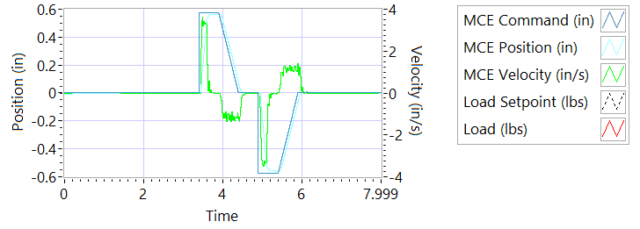

Figure - Results for Motor Three

**Step j – 225 lbf tension - Extension**

|  |  |  |  |
| --- | --- | --- | --- |
| **MCE3 – Step Response Tension Extension** | | | |
| **Requirements** | **Results** | | |
| **Description** | **Actual Speed / Time** | **Units** | **Pass/Fail** |
| No Load speed is 2.7 to 3.3 in/sec | 3.2436 | In/s | Pass |
| Time to achieve 80% of the specified stroke (+ 0.575 ins) is 170+9/-9 ms | 0.2047 | seconds | Failed |

**Step k – 225 lbf tension - Retraction**

|  |  |  |  |
| --- | --- | --- | --- |
| **MCE3 – Step Response Tension Retraction** | | | |
| **Requirements** | **Results** | | |
| **Description** | **Actual Speed / Time** | **Units** | **Pass/Fail** |
| No Load speed is 2.7 to 3.3 in/sec | -3.313 | In/s | Pass |
| Time to achieve 80% of the specified stroke (- 0.575 ins) is 170+9/-9 ms | 0.2108 | seconds | Failed |

**Step n – 225 lbf compression - Extension**

|  |  |  |  |
| --- | --- | --- | --- |
| **MCE3 – Step Response Compression Extension** | | | |
| **Requirements** | **Results** | | |
| **Description** | **Actual Speed / Time** | **Units** | **Pass/Fail** |
| No Load speed is 2.7 to 3.3 in/sec | 3.3167 | In/s | Pass |
| Time to achieve 80% of the specified stroke (+0.575 ins) is 170+9/-9 ms | 0.2108 | seconds | Failed |

**Step o – 225 lbf compression - Retraction**

|  |  |  |  |
| --- | --- | --- | --- |
| **MCE3 – Step Response Compression Retraction** | | | |
| **Requirements** | **Results** | | |
| **Description** | **Actual Speed / Time** | **Units** | **Pass/Fail** |
| No Load speed is 2.7 to 3.3 in/sec | -3.2283 | In/s | Pass |
| Time to achieve 80% of the specified stroke (-0.575 ins) is 170+9/-9 ms | 0.1938 | seconds | Failed |

**6.6.8.3.2 MCE 3 – Frequency Response Test**

**Step d – 225 lbf Tension**

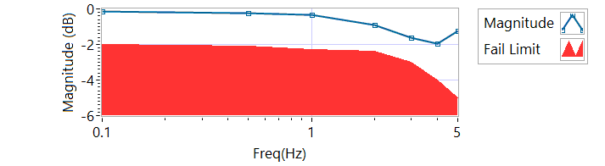

Figure - Magnitude for Motor Three Loaded Tension

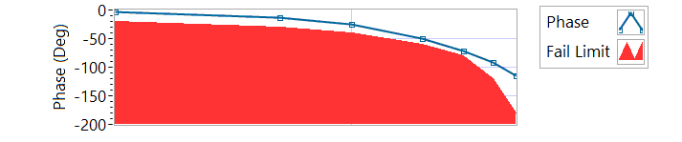

Figure - Phase for Motor Three Loaded Tension

|  |  |  |  |  |
| --- | --- | --- | --- | --- |
| **MCE 3 – Tension Frequency Response** | | | | |
| **Frequency**  **(Hz)** | **Magnitude**  **(dB)** | **Phase**  **(Deg)** | **Max Phase**  **Allowance (Deg)** | **Pass/Fail** |
| 0.1 HZ | -0.156215 | -3.1572 | -20 | Pass |
| 0.5 HZ | -0.254204 | -13.212 | -30 | Pass |
| 1 HZ | -0.353312 | -25.272 | -40 | Pass |
| 2 HZ | -0.927185 | -49.176 | -60 | Pass |
| 3 HZ | -1.6236 | -71.604 | -80 | Pass |
| 4 HZ | -1.95615 | -92.16 | -120 | Pass |
| 5 HZ | -1.25816 | -114.84 | -180 | Pass |

**Step h – 225 lbf Compression**

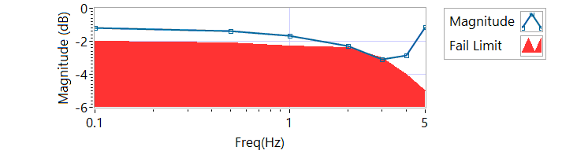

Figure - Magnitude for Motor Three Loaded Compression

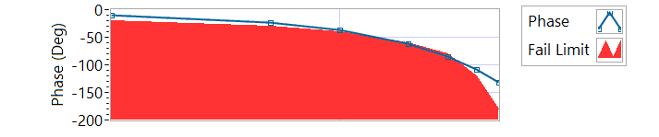

Figure - Phase for Motor Three Loaded Compression

|  |  |  |  |  |
| --- | --- | --- | --- | --- |
| **MCE 3 – Compression Frequency Response** | | | | |
| **Frequency**  **(Hz)** | **Magnitude**  **(dB)** | **Phase**  **(Deg)** | **Max Phase**  **Allowance (Deg)** | **Pass/Fail** |
| 0.1 HZ | -1.18971 | -10.8324 | -20 | Pass |
| 0.5 HZ | -1.37992 | -23.166 | -30 | Pass |
| 1 HZ | -1.65672 | -36.612 | -40 | Pass |
| 2 HZ | -2.30932 | -61.128 | -60 | Failed |
| 3 HZ | -3.0836 | -85.644 | -80 | Failed |
| 4 HZ | -2.84329 | -107.856 | -120 | Pass |
| 5 HZ | -1.15027 | -131.22 | -180 | Pass |

**6.6.9 Backlash**

6.6.9.1 **Simplex Brake 1 – ON; Duplex brake 2 – OFF**

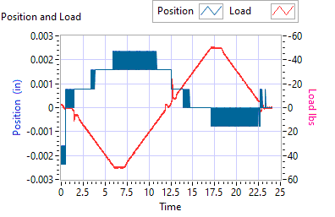

Figure - Backlash Simplex brake 1 On, Duplex brake 2 Off

|  |  |  |  |  |  |
| --- | --- | --- | --- | --- | --- |
| **Simplex Brake 1 – ON; Duplex brake 2 – OFF** | | | | | |
| **Requirements** | | | **Results** | | |
| **Step** | **Expected** | **Tolerance** | **Actual** | **Units** | **Pass/Fail** |
| Step e +/- 35 lbf tension (motor 2 and motor 3 ZERO position) | 0.0144 | 0.005 | 0.0024 | in | Pass |
| 35 | 5 | 50.2757 | lbf | Pass |
| Step e +/- 25 lbf compression (motor 2 and motor 3 ZERO position) | 0.0144 | 0.005 | 0 | in | Pass |
| 35 | 5 | -49.7764 | lbf | Pass |

6.6.9.2**Simplex Brake 1 – OFF; Duplex Brake 2 – ON**

|  |  |  |  |  |  |
| --- | --- | --- | --- | --- | --- |
| **Simplex Brake 1 – OFF; Duplex Brake 2 – ON** | | | | | |
| **Requirements** | | | **Results** | | |
| **Step** | **Expected** | **Tolerance** | **Actual** | **Units** | **Pass/Fail** |
| Step e +/- 35 lbf tension  (motor 1 ZERO position) | 0.0144 | 0.005 | 0.026 | in | Pass |
| 35 | 5 | 50.1568 | lbf | Pass |
| Step e +/- 35 lbf compression  (motor 1 ZERO position) | 0.0144 | 0.005 | 0.022 | in | Pass |
| 35 | 5 | -49.6431 | lbf | Pass |

6.6.9.3 **Both Brakes OFF**

|  |  |  |  |  |  |
| --- | --- | --- | --- | --- | --- |
| **Both Brakes OFF** | | | | | |
| **Requirements** | | | **Results** | | |
| **Step** | **Expected** | **Tolerance** | **Actual** | **Units** | **Pass/Fail** |
| Step e +/- 35 lbf tension  (motor 1 and motor 2 holding ZERO position) | 0.0144 | 0.005 | Unhandled Type: Void | in | Unhandled Type: Void |
| 35 | 5 | Unhandled Type: Void | lbf | Unhandled Type: Void |
| Step e +/- 35 lbf compression  (motor 1 and motor 2 holding ZERO position) | 0.0144 | 0.005 | Unhandled Type: Void | in | Unhandled Type: Void |
| 35 | 5 | Unhandled Type: Void | lbf | Unhandled Type: Void |